**The SAFETY App 1.0**

**The target audience:**

The SAFETY App is an emergency app, a personal safety app designed to keep you and your friends and family safer 24/7. This has been designed for a person who might find themselves in some dangerous situation. This mobile app will not be able to remove the danger or resolve the problem you are facing, but this safety app will surely help you get help to rescue yourself from the undesirable conditions you are in.

**Features**

The safety app has been packed with features for both everyday safety and real emergencies, making it the ultimate safety tool for you and everyone you love.

1. You can send distress messages to your friends and family in times of trouble.

For example, you sense somebody following you while on the way back home late at night. It might be your predator. So, with the click of a button, you can send messages to a number of your friends, family saying you are in danger and need help.

The best thing about this feature is that the message will also include a google map link stating your present location.

The same alerting can also be done through emails.

You will have an option to select your emergency contacts, so that the distress emails and messages are sent to the right people who could come to your rescue.

You will need to have your location services enabled for the optimum usage of this feature. If you do not have your GPS on, this will still send the distress messages/emails but without the location.

1. You can click the PANIC button which will set off an alarm that sounds a siren.

This will alert the people around you who could come to your help. It could also frighten off your predator who might mistake it to be a cop car. This works even when your phone is on the silent mode. [Media sounds need to be enabled.]

If you clicked on the button by mistake, clicking it again will switch off the siren.

1. You can get to know your present location if you are lost.

The google maps gives you your present location too but the safety app will give you the detailed location without you having to figure it out from the maps.

The safety app gives you details of stating which country, state, region, city, street, and lane/avenue you are in. It also gives you the postal code of the area.

You also get additional details like the latitude, longitude and altitude. There is a button “Show on map”, which takes you to your location in google maps.

Location services need to be enabled to get the data regarding your present location.

1. You can call 911, women helpline or even your emergency contact from this safety app.

Speed dials might be more helpful in this case but all the other features you get in this app make up for it.

It is advisable to set up your own emergency contact so that call is made to the right person in times of danger.

1. You can educate yourself by going through some safety tips for more awareness. We would keep adding and updating this as and when required.
2. You can rate this app and provide feedback so that we can help you to keep yourself and your friends the safest! [Work in Progress.]
3. When you are using the safety app for the first time, you will be requested to complete your profile. You will be asked to provide information like name, emergency contacts etc. so that we can include it in the distress mails and messages we sent. The mobile numbers you provide will be set up as the ones to whom the distress messages will be sent. They will also act your emergency call-to number. Email addresses provided by you will be the emergency send-to distress mail ids.

However, it is not mandatory to fill up your profile before you can use the safety app.

But completing up your profile before you start using the safety app is preferred for you to take optimum advantage of services provided by this app. After completing your profile, you could also edit your profile whenever you want.

However, we are still working on the profile feature. So as of now, you have to use the safety app without the profile feature.

[Work in progress.]

**What the safety app really looks like:**

**The HOME screen**

This screen tells you that this app works best with the location services enabled.

So please switch on your GPS! ☺

The home screen takes you to all the other screens:

* The screen to send distress messages/mails.
* The screen to the panic button.
* The screen to know your present location.
* The screen to make SOS calls.
* The screen to learn more about the safety tips.
* The screen to rate our app and provide feedback.

There is a home button present on all the main screens to take you to the home page. The device back button does the same thing too.

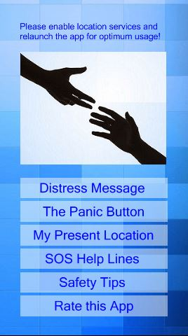

**The DISTRESS MESSAGE screen**

This screen helps you inform friends and family that you are in danger

* You can send messages to your emergency contacts and other helplines with the click of a button. The location is included if you have your GPS on. Otherwise, a message saying “I am in danger. Please help!” is sent.
* You can send emails to your emergency contacts and others with the click of a button. The content of the mail is similar to messages with/without location.

However, you would have to press the send button for finally sending the native messages/emails. They would be pre populated with the text and numbers.

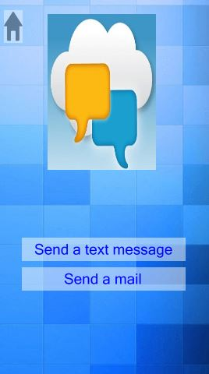

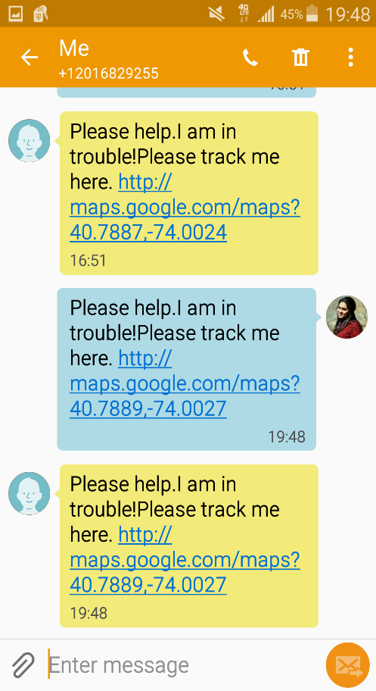 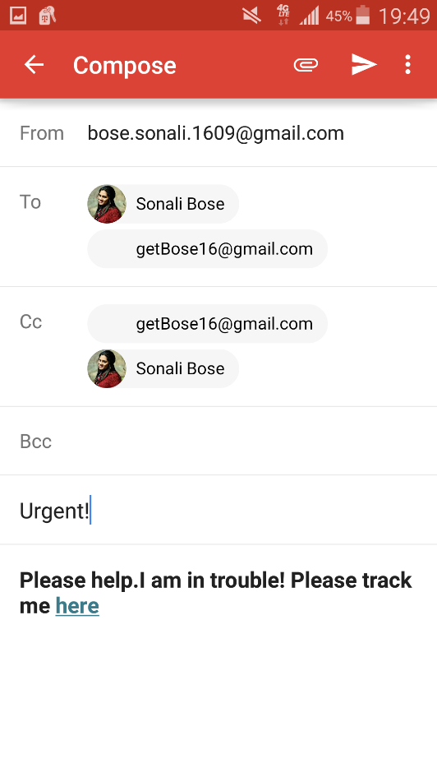

**The PANIC BUTTON screen**

This screen provides you with a panic button. Click the button when you sense danger. It might help you ward off your predator or alert other people around you who could come to your rescue.

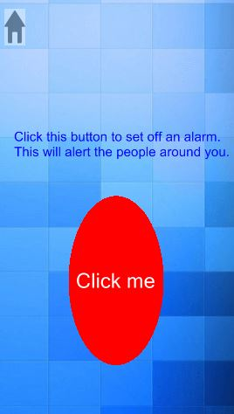

**The PRESENT LOCATION screen**

This screen will show you every detail of your present location.

* Latitude
* Longitude
* Altitude
* Country
* State
* City
* Area
* Street
* Lane/Avenue
* Zip

There is also a “Show on Map” button to locate you on the google maps.

However, this screen will not give any data if the location services are not enabled.

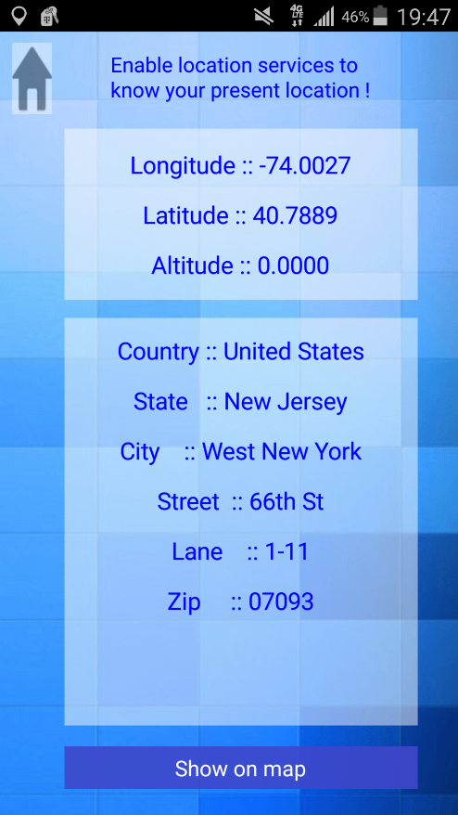

**The SOS CALLS screen**

Make calls to 911, women helpline, your emergency contacts etc. with a click of a single button.

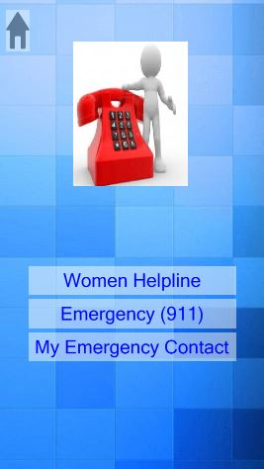

**The SAFETY TIPS screen**

This screen educates you on the dos and don’ts you need to follow to keep yourself safer.

* There is a slideshow of the prime tips for women safety.

12 slides motivate you to stand up against your predator.

* There is also a list of safety tips for spreading awareness.

 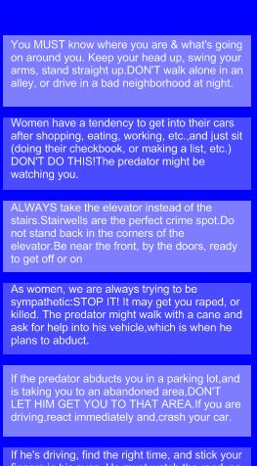

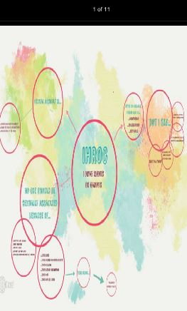

**SCOPE**

Presently this safety app with only adhere to android users. We are working towards releasing an iOS app too.

Work on functionalities like “Rate this app” and “User Profile” are in progress. Hence, you cannot use these features now in the present version of the app.

We are looking forward to release version 1.1 with these added functionalities and cross platform compatibility.

**CONCLUSION**

The SAFETY app is a full package. It is bundled with a number of features to ensure safety during times of trouble.

With this mobile app you are provided with a single place from where you could make SOS calls to 911 and your mom, send emergency messages/mails with your present location to a friend, sound an alarm to ward off your predator who has been following you on a deserted road, get to know the absolute details of your present location if you are lost in an unknown neighborhood, and last but not the least educate yourself on the precautionary measures to ensure a safer YOU.